Trigger 1 (Audit Table)

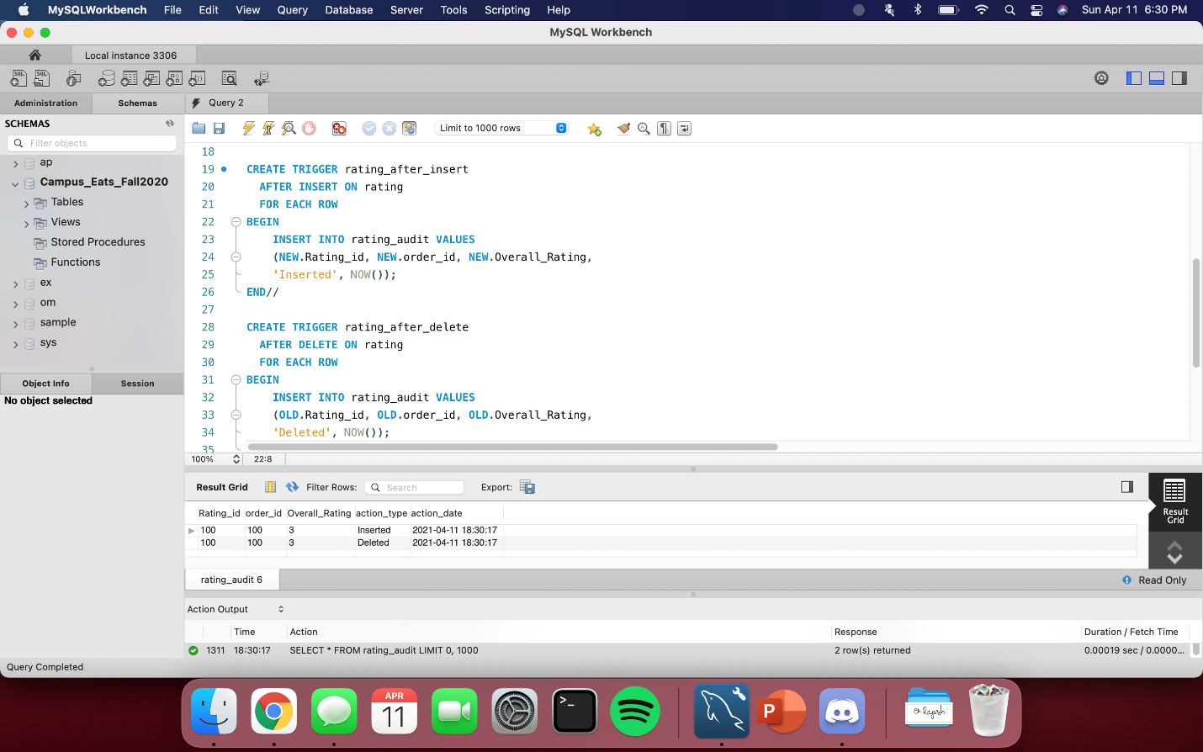

Trigger 2

